Intruder Detection System

Abstract:
Due to the advance of information and communication techniques, sharing information through online has been increased. As a result, various online services were created. However, as increasing connection points to the internet, the threats of cyber security have also been increasing. Intrusion Detection Systems (IDS) have nowadays become a necessary component of almost every security infrastructure. Intrusion detection plays an important role in ensuring information security, and the key technology is to accurately identify various attacks in the network. Analyzing network flows, logs, and system events has been used for intrusion detection. Network flows, logs, and system events, etc. generate big data. Big Data analytics can correlate multiple information sources into a coherent view, identify anomalies and suspicious activities, and finally achieve effective and efficient intrusion detection. In this project, I am trying to construct an IDS model with Machine learning algorithms in Big Data Analytics. In this project, I explore how to model an intrusion detection system based on Random Forest (RF). Random Forest (RF) is an ensemble classifier and performs well compared to other traditional classifiers for effective classification of attacks. To evaluate the performance of our model, I will conducted experiments on KDD99 data set. Empirical result show that proposed model is efficient with low false alarm rate and high detection rate.
Related domain of study: Network Security Analytics

Why Security Analytics?:

Currently information security is crucial to all organization to protect their information and conducts their business. Information security is defined as the protection of information and the system, and hardware that use, store and transmit that information. Information security performs four important for an organization which is protect the organization’s ability to function, enable the safe operation of applications implemented on the organization’s IT systems, protect the data the organization collect and uses, and lastly is safeguards the technology assets in use at the organization. There are also challenges and risk involves in implemented information security in organization. To get rid of these risks Intrusion Detection Systems (IDS) have nowadays become a necessary component of almost every security infrastructure. Intrusion detection plays an important role in ensuring information security, and the key technology is to accurately identify various attacks in the network.

Algorithm Random Forest Importance:

Random forest (RF) is an ensemble classifier used to improve the accuracy. Random forest consists of many decision trees. Random forest has low classification error compared to other traditional classification algorithms. Number of trees, minimum node size and number of features used for splitting each node. Advantages of RF are listed below:
1) Generated forests can be saved for future reference.
2) Random forest overcomes the problem over fitting.
3) In RF accuracy and variable importance is automatically generated.
When constructing individual trees in random forest, randomization is applied to select the best node to split on. This value is equal to √A, where A is no. of attributes in the data set. However, RF will generate many noisy trees, which affect accuracy and wrong decision for new sample. Below are the estimated accuracy of detection rate for several attacks. So I choose these algorithms in my project.
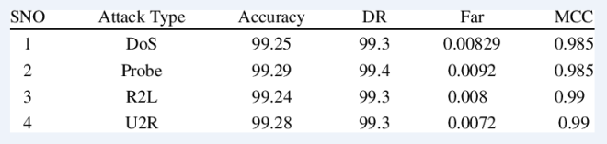

Steps of procedure:

Feature selection:

Feature selection (FSS) is a pre-processing step commonly used in data mining. It is effective in dimensionality reduction and removes irrelevant features thus increases accuracy. It refers to the problem of identifying those features that are useful in predicting class.

Proposed approach:
Research framework for our proposed method is shown in Fig. 1.
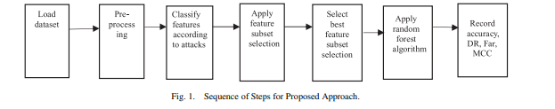
Our proposed algorithm is described below
Algorithm: Random forest modeling for network IDS
Input: KDD99 dataset
Output: Classification of different type of attacks
Step 1: Load the dataset
Step 2: Apply pre-processing technique Discretization
Step 3: Cluster the dataset into four datasets.
Step 4: Partition the data set into training and test
Step 5: Select the best set features using feature subset selection measure Symmetrical uncertainty (SU) Symmetrical uncertainty compensates information gain
SU(X, Y) = 2[I G(X/Y)/H(X)H(Y )]
Step 6: Data set is given to Random forest for training
Step 7: The test data set is then fed to random forest for classification
Step 8: Calculate accuracy score, recall, precision, f-measure.

Data Preprocessing:

- Numericalization: There are 41 numeric features KDD dataset. Because the input value of RNN-IDS should be a numeric matrix, we must convert some non-numeric features, such as ‘protocol_type’, ‘service’ and ‘flag’ features, into numeric form. For example, the feature ‘protocol_type’ has three types of attributes, ‘tcp’, ‘udp’, and ‘icmp’, and its numeric values are encoded as binary vectors (1,0,0), (0,1,0) and (0,0,1). Similarly, the feature ‘service’ has 70 types of attributes, and the feature ‘flag’ has 11 types of attributes. Continuing in this way, 41-dimensional features map into 122-dimensional features after transformation.
- Normalization: First, according to some features, such as ‘duration[0,58329]’, ‘src_bytes[0,1.3×109 ]’ and ‘dst_bytes[0,1.3×109 ]’, where the difference between the maximum and minimum values has a very large scope, we apply the logarithmic scaling method for scaling to obtain the ranges of ‘duration[0,4.77]’, ‘src_bytes[0,9.11]’ and ‘dst_bytes[0,9.11]’. Second, the value of every feature is mapped to the [0, 1] range linearly according to (1), where Max denotes the maximum value and Min denotes minimum value for each feature.
xi=xi−Min/Max−Min(1) (1)

Evaluation Metric:
Using the test data to make predictions of the model. Multiple scores are considered such as: accuracy score, recall, precision, f-measure.
- Accuracy = Samples correctly classified in test data/Number of samples in test data

- Recall = Recall is intuitively the ability of the classifier to find all the positive samples.

- Precision = Precision is intuitively the ability of the classifier not to label as positive a sample that is negative.

- F-measure = Relative contribution of precision and recall to the F1 score are equal. The formula for the F1 score is:

F1 = 2 * (precision * recall) / (precision + recall)

Where TN → True negative, FN → False negative, FP → False positive, TP → True Positive.

Data sources:

Possible data sources: KDDCUP99 Datasets

URLs:

https://www.kdd.org/kdd-cup/view/kdd-cup-1999/Data

http://archive.ics.uci.edu/ml/datasets/KDD%2BCup%2B1999%2BData

http://kdd.ics.uci.edu/databases/kddcup99/kddcup99.html

https://data.world/uci/kdd-cup-1999-data

Dataset Description:

KDD Cup 1999 dataset has been used to measure a performance of IDS in many researches. Although the dataset is old, it is good to compare the IDS models. Because there are lots of performance measurement results with the same dataset. That is the main reason why I choose KDD Cup 1999 dataset. There are 4,898,431 network traffics in the dataset and each traffic has 41 features. And 22 attacks are categorized according to their characteristic. Below table shows the category of the attacks. DoS attack depletes resources of the target servers and makes them precluding any services. R2L attack enables an unauthorized remote access. U2R attack tries to acquire the super user authority. Probe attack uses for finding vulnerabilities of the target server.
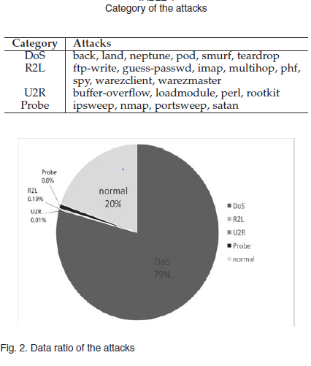
Because there are too many data records in the original dataset, we use KDD Cup 1999 10 percent data for training and testing. However, the data ratio of the attacks is weighted towards DoS attack. And the others ratio is only 1 percent. It is shown in Figure 2. So the IDS model will be trained unfairly. As a result, DoS attack and normal traffic can easily be detected but the other attacks cannot be caught. In order to solve this problem, we generate a new training dataset evenly. I extract 300 instances from each attack category except U2R attack. Due to the lack of instances, I only extract 30 data from U2R category. Also, we use 1,000 normal instances.

Samples of Data Source:

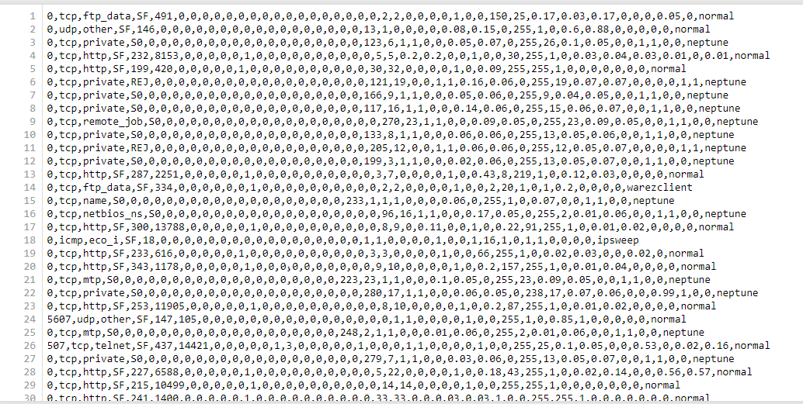
The input vector is 41 features and the output vector is composed of 4 attacks and 1 non attack. Therefore, the input dimension is 41 and the output dimension is 5.

Transforming the data:
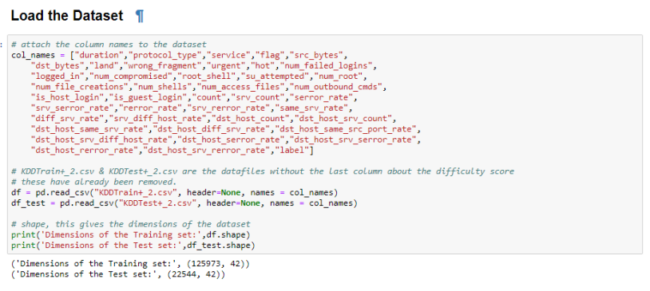
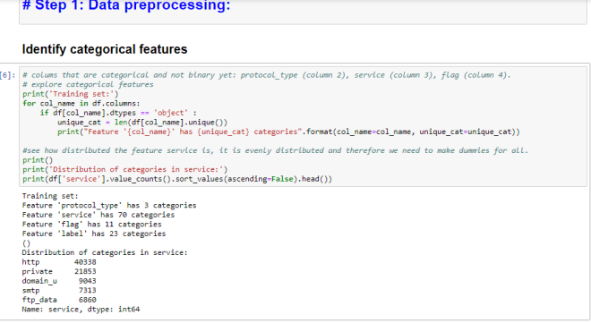

Output:
I will Train the model, and the output will be percentage of accuracy each attack type which are from the dataset. I am planning to create a bar graph where it has attack category in x-axis and percentage in y-axis.

Current challenges:

I removed all the null characters, comma separators and split the data for each comma, so I get data for each feature. I categorized each service and feature to each attack category. I will create three separate datasheets which will help during training phase and testing phase those are:
- attack types(normal,dos,probe,u2r,r2l)
- Attack and the type(back dos ,buffer_overflow u2r,ftp_write r2l, guess_passwd r2l, imap r2l,ipsweep probe)
- services and features

Need to make dummies for all categories as the distribution in even. In total: 3+70+11=84 dummies.

Conclusions:

This project deals the Random Forest (RF) algorithm to detect four types of attack like DOS, probe, U2R and R2L. Feature selection is applied on the data set to reduce dimensionality and to remove redundant and irrelevant features. We applied symmetrical uncertainty of attributes which overcomes the problems of information gain. The proposed approach is evaluated using KDD 99 data set. We compared our random forest modelling with Decision trees algorithm classier in terms of accuracy score, recall, precision, f-measure, I will try to apply evolutionary computation as a feature selection measure to further improve accuracy of the classifier.

Motivation:

Intrusion Prevention System: Intrusion Prevention System (firewall) can prevent all attacks. An IPS has capability to detect and prevent misuse and abuse of, and unauthorized access to, network resources. A network administrator intervention is not needed to stop misuse, abuse and unauthorized access. Administrator examines the alerts that are generated by IPS.

References:

[1]Random Forest Modeling for Network Intrusion Detection System Nabila Farnaaz and M. A. Jabbar.
[2]Network Intrusion Detection using Random Forests Jiong Zhang and Mohammad Zulkernine School of Computing Queen’s University, Kingston Ontario, Canada K7L 3N6
[3]Semi-supervised Random Forest for Intrusion Detection Network :Ningxin Shi, Xiaohong Yuan, William Nick North Carolina Agricultural and Technical State University
[4] Bai, Yuebin, and Hidetsune Kobayashi, Intrusion detection systems: technology and development, AINA 2003. 17th International Conference on. IEEE, 2003
[5] Depren, Ozgur, et al., An intelligent intrusion detection system (IDS) for anomaly and misuse detection in computer networks, Expert systems with Applications 29.4, pp.713-722, 2005
[6] Liao, Yihua, and V. Rao Vemuri, Use of k-nearest neighbor classifier for intrusion detection, Computers & Security 21.5, pp.439-448, 2002

